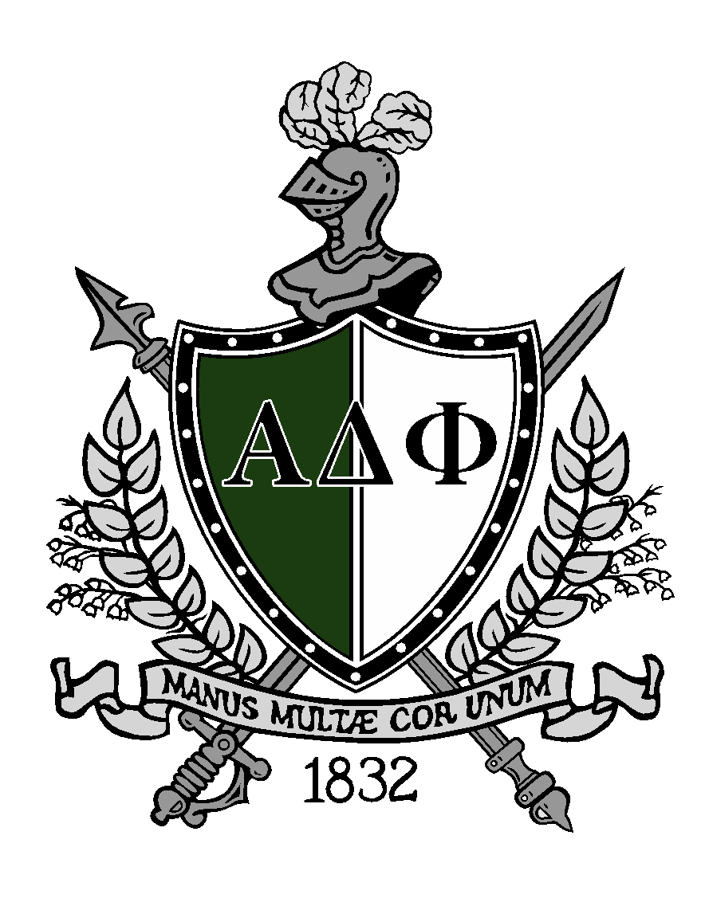
Alpha Delta Phi 2010 Endowment Fund Presents
The Kent Parker Memorial Scholarship
Application Form 2023-2024
About the Fund:
The ‘Alpha Delta Phi 2010 Endowment Fund’ was created by the Alpha Delta Phi, UBC Alumni Association in coordination with the Active (Student) Chapter following the 2010 Winter Olympics. During the Vancouver Olympics the Fraternity house was rented to a private company, and the proceeds established the Endowment fund to provide scholarships to young leaders.

Description of the award:
Awarded to a UBC Undergraduate Student that has exemplified leadership in a UBC campus or a Vancouver community organization. Successful applicants are active community members and balance both athletic and academic achievement.

About Kent Parker:
Kent Parker was an Alpha Delta Phi BC Chapter Fraternity member during his undergraduate degree at UBC in the late 1980s. His dedication to Campus Leadership continued after graduating in his role as Chapter Service Consultant (CSC), working for Alpha Delta Phi International and travelling across North America coaching young leaders on multiple campuses. He later served as a Governor of Alpha Delta Phi International

Award Value 2023-2024: $3400, 1 recipient

Alpha Delta Phi University Award Eligibility:
- Full time, Returning, University of British Columbia (UBC) Vancouver Campus Student
  - 3+ Courses/Semester in the 2023-2024 Academic Year
  - Returning Student (Year 2+)
- Currently Holding a Senior or Executive Role in a UBC Club or Non-UBC Vancouver Organization
- Minimum Cumulative Average of 65%
- Deadline: May 31st 11:59pm Vancouver time.
** Past Kent Parker Memorial Scholarship winners are NOT eligible.

Information :
- Applications will be reviewed by the Alpha Delta Phi Alumni Scholarship Committee and more information on the committee can be found at alumni.alphadelt.ca/scholarships.
- Send applications to:
Ryan Fetterly, Scholarship Committee Chairman
E-mail: scholarships@alphadelt.ca
Applications must include all supporting documentation in one (1) e-mail in English.

Applicant Checklist:
- Application form (Complete), Pages 2 & 3 (Typed)
- Resume (2 Pages Maximum)
- Unofficial transcript from the university. (Screenshot, ALL Courses Included)
- References (3)

Follow Up & The Award:
- Scholarship Applicants will be informed by e-mail that their application has been received. The Winner will be notified by late June 2023.
- The Winner will receive a ‘Certificate of Registration’ from the Vancouver Foundation, our financial partner that will be utilized by UBC’s registrar’s office to credit the winner’s Tuition, Housing or Meal Plan expenses at UBC.

Personal & Academic Information:
Name (First) |  | Name (Surname)
Student ID # |  | 2023-2024 Academic Year
Telephone (CELL) |  | E-mail
Major(s) |  | Minor(s)
Cumulative Average (%) |  | Faculty

Extracurricular Involvement:
List three (3) organizations where you are actively involved in a leadership or volunteering capacity. Include length of commitments (month/year – month/year), monthly commitment (hours) and roles. Minimum 1-2 references should be from these organizations. (Maximum 150 words per organization)

Awards, Honors, Scholarships & Publications:
List any Community Awards, Athletic Awards or Academic Publications received while at UBC.

Example:
- Award Name, Award Description, Day/Month/Year

Written Section
Topic: “Leadership in Times of Crisis”
Criteria: 350 to 500 Words

References:
Include Name, E-mail, Phone Number, Relationship to Applicant.

I certify that the information provided in this scholarship application is accurate to the best of my knowledge.

Signature Date

Submission Requirements:
E-mail Title: Alpha Delta Phi 2010 Scholarship – Applicant Last Name
Place all requirements into 1 document – preferably a PDF.
- File Name Format: ADP2024.LastName.FirstName

